Name:- Tanishka Kadam
PRN No.: 124B2D001
FSD Assignments

- ASSIGNMENT 1 – BASIC
Create a simple webpage
- Change background color
- Style headings and paragraphs
- Use class and ID selectors
Concepts: selectors, colors, fonts
<!DOCTYPE html>
<html>
<head>
<title>Assignment 1 - Basic CSS</title>
<style>
body {
background-color: lightblue;
font-family: Arial;
}

h1 {
color: darkblue;
}

.para {
color: green;
font-size: 16px;
}

#special {
color: red;
font-weight: bold;
}
</style>
</head>
<body>

<h1>Welcome to CSS</h1>

<p class="para">This is a paragraph styled using class selector.</p>

<p id="special">This paragraph is styled using ID selector.</p>

</body>
</html>
OUTPUT:
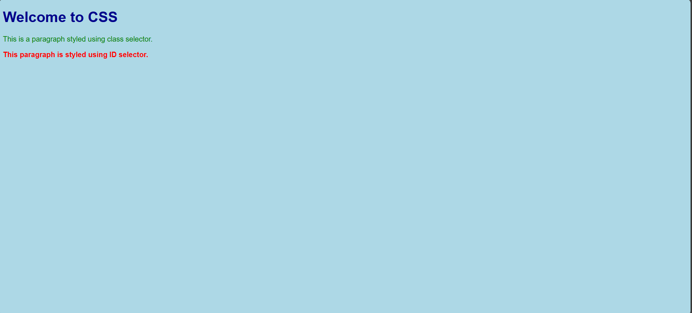

- ASSIGNMENT 2 – BOX MODEL
Design a card
- Fixed width
- Padding &amp; margin
- Border and shadow
Concepts: box model
<!DOCTYPE html>
<html>
<head>
<title>Assignment 2 - Box Model</title>
<style>
.card {
width: 300px;
padding: 20px;
margin: 40px;
border: 2px solid black;
box-shadow: 5px 5px 10px gray;
background-color: white;
}
</style>
</head>
<body>

<div class="card">
<h2>CSS Card</h2>
<p>This card demonstrates the CSS box model.</p>
</div>

</body>
</html>
OUTPUT:
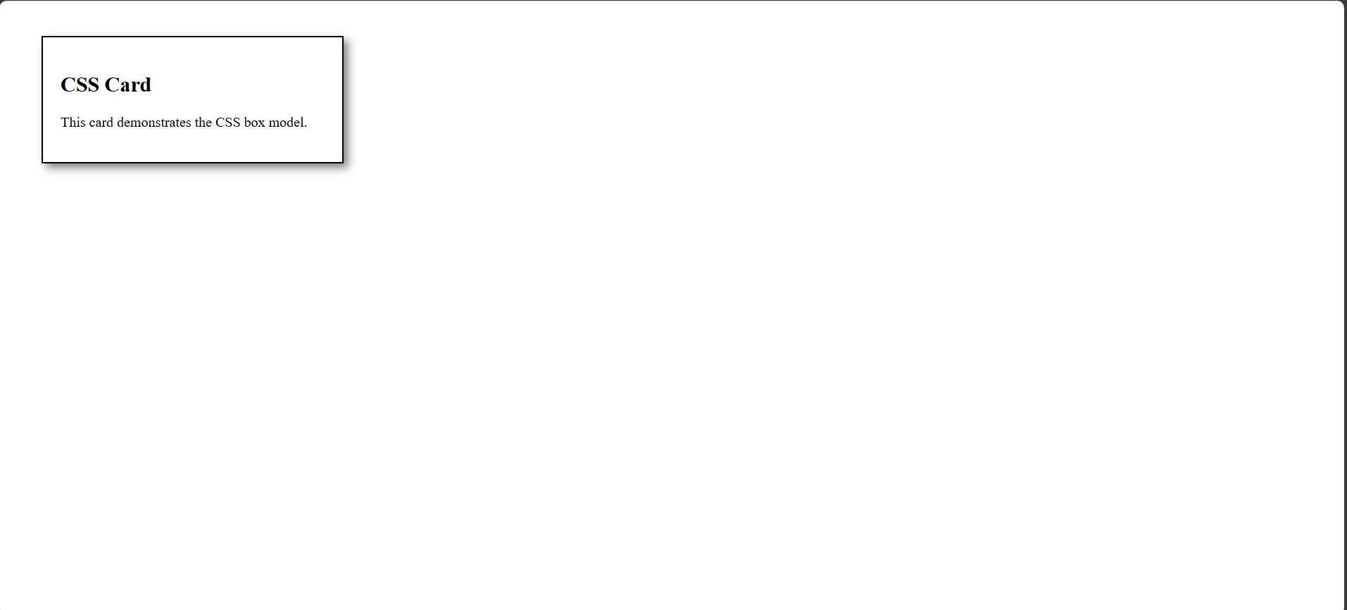
- ASSIGNMENT 3 – FLEXBOX
Create a navigation bar
- Logo on left
- Menu items on right
- Responsive layout
Concepts: flexbox

<!DOCTYPE html>
<html>
<head>
<title>Assignment 3 - Flexbox</title>
<style>
.navbar {
display: flex;
justify-content: space-between;
align-items: center;
background-color: #333;
padding: 10px 20px;
}

.logo {
color: white;
font-size: 20px;
}

.menu a {
color: white;
margin-left: 15px;
text-decoration: none;
}
</style>
</head>
<body>

<div class="navbar">
<div class="logo">MyLogo</div>
<div class="menu">
<a href="#">Home</a>
<a href="#">About</a>
<a href="#">Contact</a>
</div>
</div>

</body>
</html>
OUTPUT:
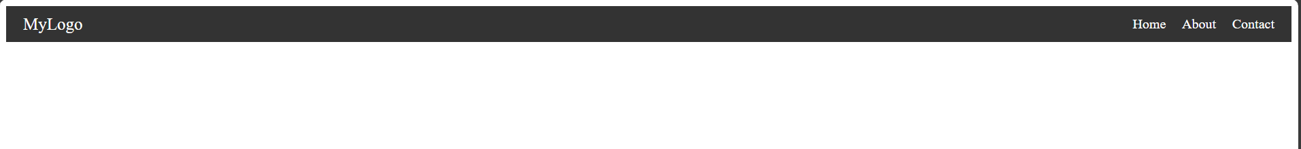
- ASSIGNMENT 4 – GRID
Image gallery
- 3-column layout
- Responsive grid
- Gap between images
Concepts: CSS Grid
<!DOCTYPE html>
<html>
<head>
<title>Assignment 4 - Grid</title>
<style>
.gallery {
display: grid;
grid-template-columns: repeat(3, 1fr);
gap: 10px;
}

.gallery div {
background-color: lightgray;
height: 180px;
text-align: center;
line-height: 100px;
font-size: 20px;
overflow: hidden;
}
.gallery img{
width: 100%;
height: 100%;
object-fit: cover;
}
@media (max-width: 768px) {
.gallery {
grid-template-columns: repeat(1, 1fr);
}
}
</style>
</head>
<body>

<div class="gallery">
<div><img src="img1.jpg"></div>
<div><img src="img2.jpg"></div>
<div><img src="img3.jpg"></div>
<div><img src="img4.jpg"></div>
<div><img src="img5.jpg"></div>
<div><img src="img6.jpg"></div>
</div>

</body>
</html>
OUTPUT:


- ASSIGNMENT 5 – RESPONSIVE DESIGN
Landing page
- Mobile &amp; desktop views
- Use media queries
- Flexible units
Concepts: responsive design
<!DOCTYPE html>
<html>
<head>
<title>Assignment 5 - Responsive Design</title>
<style>
body {
font-family: Arial;
background-color: white;
}

.container {
width: 80%;
margin: auto;
padding: 20px;
background-color: lightblue;
}

@media (max-width: 600px) {
body {
background-color: lightgray;
}

.container {
width: 95%;
}
}
</style>
</head>
<body>

<div class="container">
<h1>Landing Page</h1>
<p>This page adjusts based on screen size.</p>
</div>

</body>
</html>
OUTPUT:
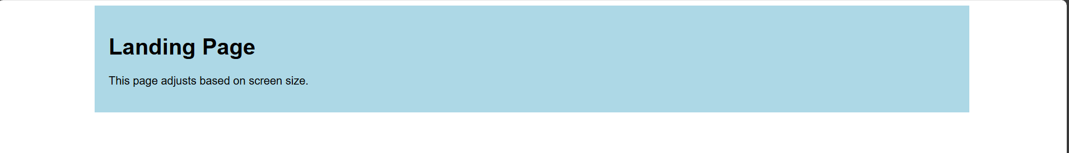
- ASSIGNMENT 6 – ANIMATION
Interactive button
- Hover animation
- Transition effects
- Keyframe animation
Concepts: animation &amp; transition
<!DOCTYPE html>
<html>
<head>
<title>Assignment 6 - Animation</title>
<style>
button {
padding: 10px 20px;
font-size: 16px;
background-color: blue;
color: white;
border: none;
transition: background-color 0.3s;
position: relative;
}

button:hover {
background-color: green;
animation: move 0.5s;
}

@keyframes move {
from { left: 0; }
to { left: 20px; }
}
</style>
</head>
<body>
<button>Hover Me</button>
</body>
</html>
OUTPUT:
